IMO- SingleStore
INTRODUCTION
SingleStore DB is a cloud-native database designed for data-intensive applications. A distributed, relational, SQL database management system(RDBMS) that features ANSI SQL support. Best in class Database when it comes to speed in data ingestion, transaction processing, and query processing.SingleStore stores JSON data, graph data, and time series data besides relational data. It supports blended workloads, commonly referred to as HTAP workloads, as well as more traditional OLTP and OLAP use cases. The SingleStore database engine can be run in various Linux environments, including on-premises installations, public and private cloud providers, in containers via a Kubernetes operator, or as a hosted service in the cloud known as SingleStoreDB
❖ Latency-Free Analytics: SingleStore lets you achieve ultra fast query response with high concurrency across both live and historical data using familiar ANSI SQL
❖ Ultra-fast Event-to-Insight Performance: Deliver against the toughest service level agreements using parallel, distributed lock-free ingestion and real-time query processing
❖ Scale Limitlessly: Elastic scale-out architecture with distributed massively parallel data processing delivers consistent, predictable response under high ingest and user concurrency
❖ Ease of Use and Flexibility: SingleStore TM brings simplicity and ease to your data architecture by allowing OLTP and OLAP workloads to be processed on operational data using a single table type
❖ Drop-in Compatibility: Plug-in directly with existing technologies and skills with support for standard SQL, BI and distributed technologies like Amazon S3, Spark, Kafka and Hadoop
❖ Powerful Programmability: Supports simple, fast, and powerful in-database programming via MPSQL and an extensive set of built-in data types and functions

LOGICAL ARCHITECTURE
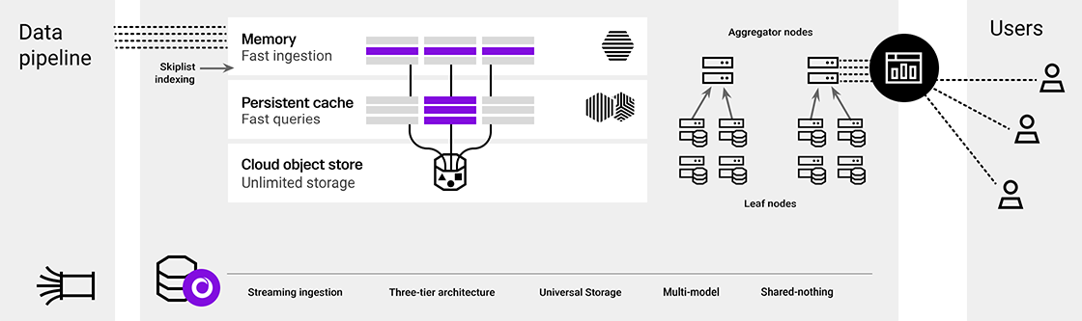
Components of Logical Architecture -
Data Pipelines - SingleStore Pipelines are a robust feature designed to continuously load data from various external sources. They allow you to extract, shape (modify), and load external data in real-time without the need for third-party ETL tools or middleware. Pipelines are highly scalable, support fully distributed workloads, and provide high performance, as data is loaded in parallel directly to the SingleStore leaves in most cases. They support exactly-once semantics, ensuring that transactions are processed precisely once, even in the event of failover. The Pipelines feature supports data sources such as Apache Kafka, Amazon S3, Azure Blob Storage, file system, Google Cloud Storage, and HDFS, and can handle formats like JSON, Avro, Parquet, and CSV
3 tier Architecture ( Memory, Persistent Cache , Object Store) - Here is a brief overview of the three tiers:
- Memory: This is where SingleStoreDB stores data for Rowstore, caches data for Columnstore, and performs operations that require the high performance of system memory. It is designed for the most immediate and high-speed data access.
- Persistent Cache: The persistent cache tier is made up of high-performance block storage, primarily serving Columnstore data and persisting Rowstore data. For optimal performance, it is recommended that the working dataset fit within the persistent cache. This layer is critical for fast access to more frequently accessed data.
- Storage: This tier provides durable and persistent long-term data storage within the cloud object storage. It is regularly used to push data to object storage for long-term retention and to enable features such as point-in-time recovery (PITR). This storage tier can accommodate data volumes that exceed the size of the active databases, including snapshots and backup data.
- Aggregator Nodes - In SingleStoreDB's distributed architecture, aggregator nodes play an important role in query processing. They are responsible for routing queries to the leaf nodes, which store and process the data, and then aggregating the intermediate results from the leaves before sending the final results back to the client
There are two types of aggregators within a SingleStoreDB cluster:
- Master Aggregator: This is a specialized node responsible for orchestrating cluster monitoring, failover, and DDL operations. There is exactly one master aggregator per cluster, and it is essential for managing the overall cluster state and metadata..
- Child Aggregator: These nodes can route queries to leaf nodes and aggregate results. Depending on the query volume, a cluster may contain zero or more child aggregators. In the event of the master aggregator's host failing, a child aggregator can be promoted to the role of master aggregator

The minimal setup for a SingleStoreDB cluster requires at least one master aggregator and one leaf node. However, additional aggregators (child aggregators) can be added to distribute the query load, which is beneficial especially in environments with a high volume of queries
Leaf Nodes - Leaf nodes in SingleStoreDB are fundamental components of the cluster's distributed architecture. Each leaf node functions as both a storage and compute node and contains several partitions of the database's data. The data within a SingleStoreDB cluster is automatically distributed across leaf nodes into these partitions, which helps in optimizing performance.

PHYSICAL ARCHITECTURE ( IMO FDA PROD )
Hardware Configuration :
2 Aggregator VM’s ( Master & Child)
4 Leaf VM’s ( 8vCpu, 32 GB RAM)

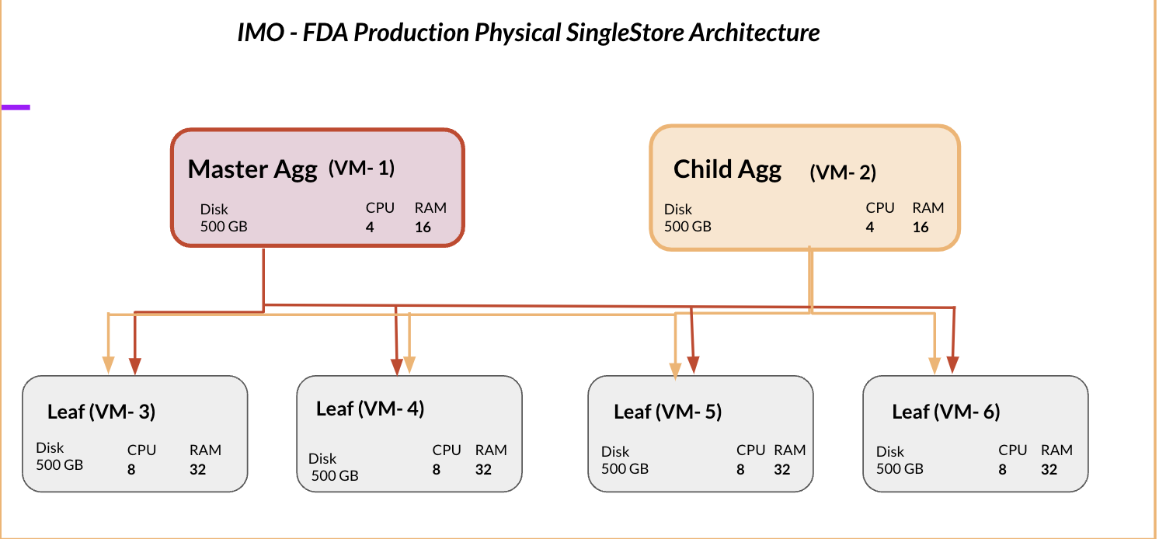

PHYSICAL ARCHITECTURE ( IMO DWH PROD )
Hardware Configuration :
2 Aggregator VM’s ( Master & Child)
8 Leaf VM’s ( 8vCpu, 32 GB RAM)

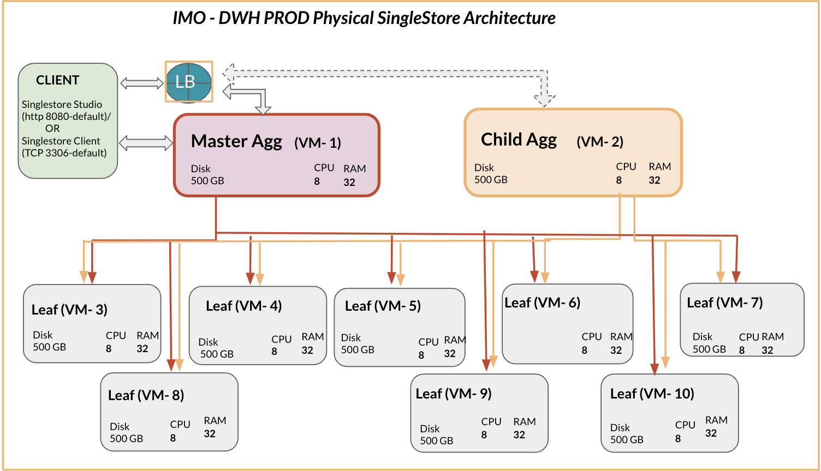

BASIC PHYSICAL ARCHITECTURE ( IMO FDA & DWH PROD )
Hardware Configuration :
2 Aggregator VM’s ( Master & Child)
2 Leaf VM’s ( 8vCpu, 32 GB RAM)

